UNIVERSITY OF WAH (UOW)

DEPARTMENT OF COMPUTER SCIENCE



BSCS 3RD B

REG #: UW-24-CS-BS-088

SUBMITTED BY: SAADI SAFDAR

SUBMITTED TO: Ms. MUNNIBA KHAN

COURSE TITLE: DATA STRUCTURES

COURSE CODE: CS – 201 L

LAB REPORT # 13

Max Heap Dry Run:
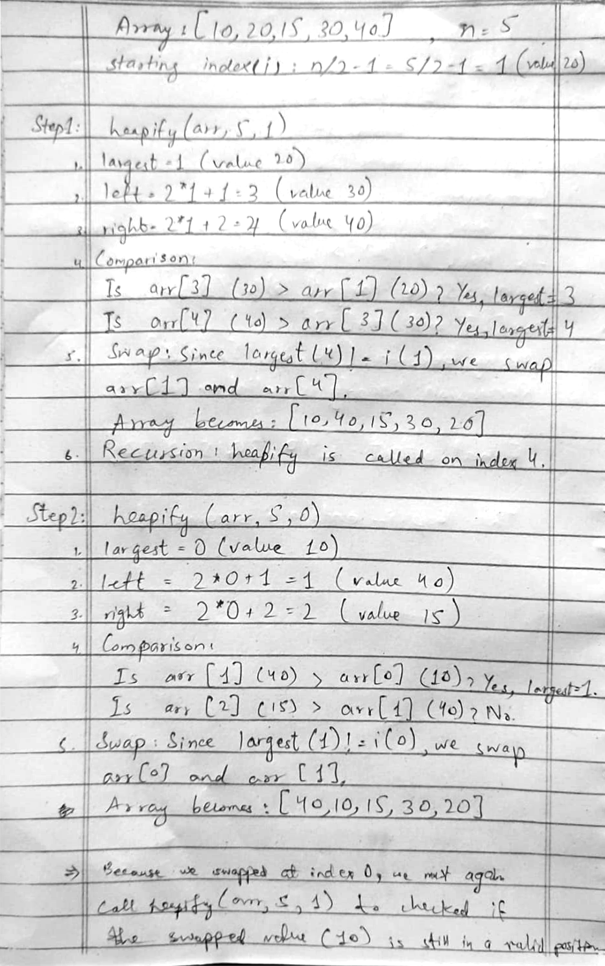

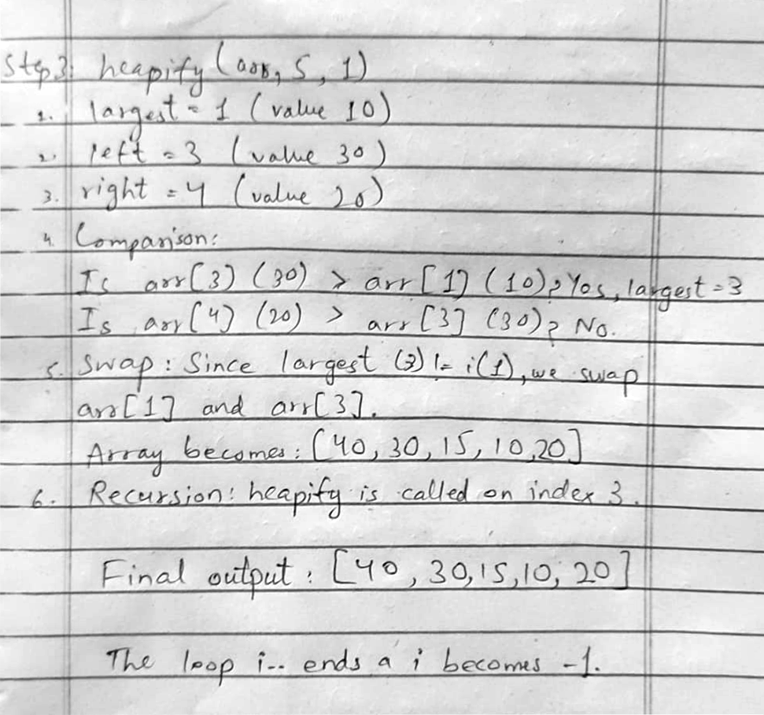
Min Heap:
#include <iostream>
using namespace std;

void heapify(int arr[], int n, int i)
{
int smallest = i;
int left = 2*i + 1;
int right = 2*i + 2;

if(left < n && arr[left] < arr[smallest])
smallest = left;

if(right < n && arr[right] < arr[smallest])
smallest = right;

if(smallest != i)
{
swap(arr[i], arr[smallest]);
heapify(arr, n, smallest);
}
}

int main()
{
int arr[] = {40, 30, 15, 20, 10};
int n = sizeof(arr)/sizeof(arr[0]);

for(int i = n/2 - 1; i >= 0; i--)
heapify(arr, n, i);

cout << "Min Heap: ";
for(int i = 0; i < n; i++)
cout << arr[i] << " ";
return 0;
}

Output:

